# CIS7 Unit 1 Lab 1

In this lab, we will continue to complete the exercises in binary arithmetic, hexadecimal conversions and twos’ complement.

1. Binary Multiplication:

**Binary Multiplication Rules**

|  |  |
| --- | --- |
| 0 x 0 = 0 | 0 x 1 = 0 |
| 1 x 0 = 0 | **1 x 1 = 1** |

**Example:**

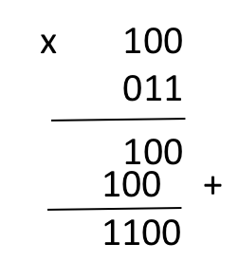

1. 1 0 1 1 1 1 0

x 1 1 0 0 0 1 0

1. 1 1 0 0 0 1

x 1 1 1 0 0 0

1. Convert the following hexadecimal to decimal values.
2. 21B16
3. A93D16
4. Convert decimal values 80110 to a hexadecimal value.
5. Convert B6116 to binary values.
6. Convert 95C216 to binary values.
7. Find the octal values for the following values:
8. 12410
9. 6210
10. 11111101
11. Find the twos’ complement of the following values:
12. 8910
13. 16110
14. 10011000
15. 11001011